October 19, 2023:

Making Mead!

presented by Jay Francis
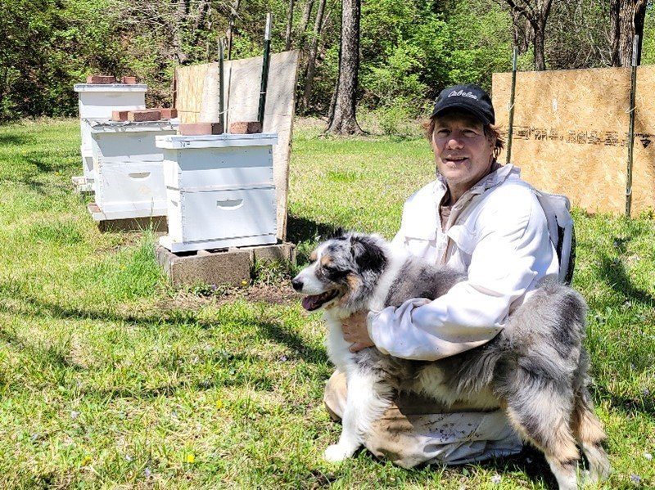
Jay began beekeeping 6 years ago and it only seemed natural to extend his wine making hobby to mead making. Now he enjoys experimenting with different fruits and honey. There is always plenty of wine and mead over the holidays at the Francis home.
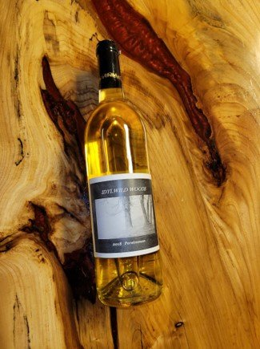
Making a quality mead or fruit wine is something that a home hobbyist can do proficiently with an understanding of how fermentation works and some specialized equipment. It is more important to understand the concept of making wine than to own “How To” books where most of the pages are dedicated to recipes. Jay will walk you through how to make a Mango Mead from start to finish.

